|  |
| --- |
| Faculty of Applied Sciences and Technology |
| **XML/JSON Data Processing** |
| ITC5202 - Project |
|  |
| **Devansh & Tim**  **Submission Date** |
| **4/24/2021** |

|  |
| --- |
| This document explains how to process XML/JSON data …………………………. |

Table of Contents

Question 1: Use JavaScript/Ajax to process XML data 2

Question 2,3,4,6: Use JavaScript/jQuery to process JSON data 3

Question 5 and 7(Bonus) : XSLT and XPath 4

Summary 5

# Question 1: Use JavaScript/Ajax to process XML data

(Describe the major steps for designing the JavaScript function(s), how you test this program, add some screenshots of the output )

**BY: TIM BURNS**

**CODE**

<!DOCTYPE *html*>

<html *lang*="en">

<head>

    <meta *charset*="UTF-8">

    <meta *http-equiv*="X-UA-Compatible" *content*="IE=edge">

    <meta *name*="viewport" *content*="width=device-width, initial-scale=1.0">

    <link *rel*="stylesheet" *href*="style.css">

    <title>Question 1 - Part 1 & 2</title>

</head>

<body *onload*="loadDoc()">

    <div *id*="wrapper">

        <p *id*="displayT"></p>

    </div>

    <script>

        function loadDoc() {

            var xhttp = **new** *XMLHttpRequest*();

            xhttp.onreadystatechange = function () {

                if (*this*.readyState == 4 && *this*.status == 200) {

                    myFunction(*this*);

                }

            };

            xhttp.open("GET", "Country.xml", true);

            xhttp.send();

        }

        function myFunction(*xml*) {

            myObj  = *xml*.responseXML;

            //console.log(myObj.getElementsByTagName("country")); // not working

            var mondial = myObj.getElementsByTagName("mondial");

            var name = myObj.getElementsByTagName("name");

            var country = myObj.getElementsByTagName("country");

            var uEmp = myObj.getElementsByTagName("unemployment");

            var tGDP = myObj.getElementsByTagName("gdp_total"); // may not exist in the xml file

            var pop = myObj.getElementsByTagName("population");

            console.log(uEmp.nodeValue);

            console.log(name);

            output1 = "<h1 style='color: white'> Question 1 - part 1 & 2 </h1>"

            output1 += "<table border='1' style='background-color: white; width: 100%'>"

              output1 += "<tr style='background-color: gold'>"

                output1 += "<th>" + "Country Name" + "</th>"

                output1 += "<th>" + "Capital" + "</th>"

                output1 += "<th>" + "Unemployment" + "</th>"

                output1 += "<th>" + "Total GDP" + "</th>"

                output1 += "<th>" + "Largest Ethnic Group" + "</th>"

              output1 += "</tr>"

              for(let i = 0; i < country.length; i++)

                {

                    //for (let j = 0; j < country.length; j++) {

                        output1 += "<tr style='background-color: white'>"

                        output1 += "<td>" + country[i].firstElementChild.innerHTML + "</td>";

                        output1 += "<td>" + country[i].getAttribute("capital") + "</td>"

                        // how do i test if it exist - no help at all

                        if (country[i].getElementsByTagName("unemployment").length == 0)

                        {

                            output1 += "<td>" + "N/A" + "</td>" ;

                        }

                        else

                        {

                            output1 += "<td>" + country[i].getElementsByTagName("unemployment")[0].innerHTML + "%" + "</td>";

                            //console.log(Country[i].getElementsByTagName("unemployment")[0].innerHTML);

                        }

                        if (country[i].getElementsByTagName("gdp_total").length == 0)

                        {

                            output1 += "<td>" + "N/A" + "</td>" ;

                        }

                        else

                        {

                            output1 += "<td>" + country[i].getElementsByTagName("gdp_total")[0].innerHTML + "</td>";

                            //console.log(Country[i].getElementsByTagName("unemployment")[0].innerHTML);

                        }

                        if (country[i].getElementsByTagName("ethnicgroup").length == 0)

                        {

                            output1 += "<td>" + "N/A" + "</td>" ;

                        }

                        else

                        {

                            output1 += "<td>" + country[i].getElementsByTagName("ethnicgroup")[0].innerHTML

                                + " - " + country[i].getElementsByTagName("ethnicgroup")[0].getAttribute("percentage")

                                + "%" + "</td>";

                        }

                        output1 += "</tr>"

                    //}

                }

               output1 += "</table>"

            document.getElementById("displayT").innerHTML += output1;

            }

    </script>

</body>

</html>

**OUTPUT (NOT ALL IN SCREENSHOT)**

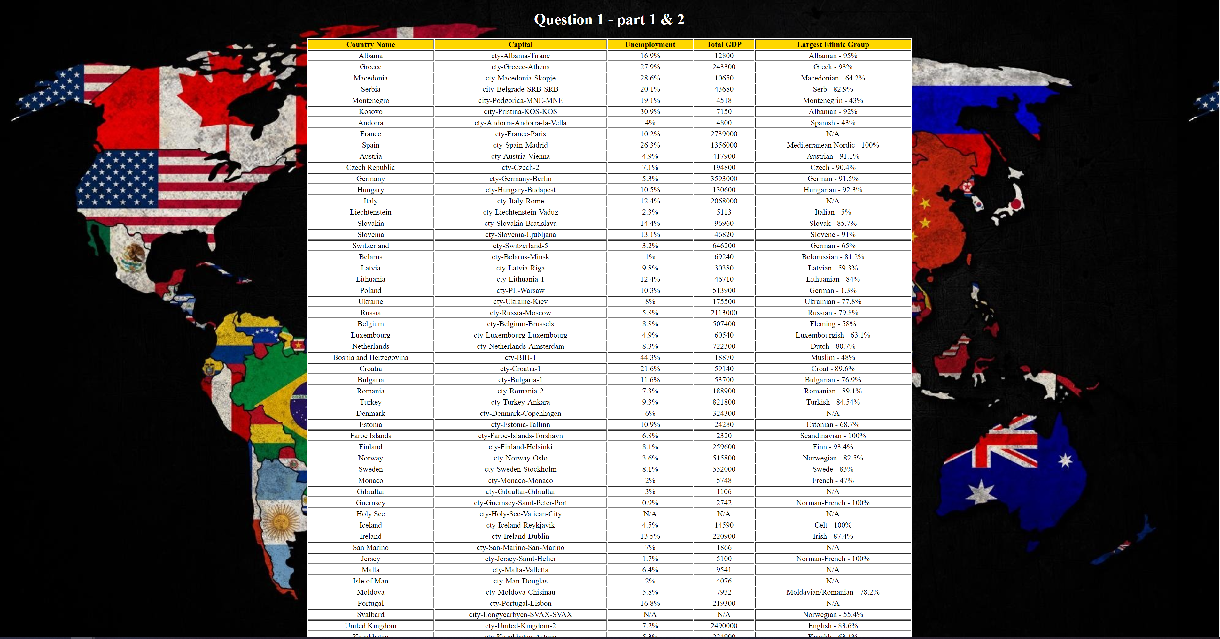

**Major Steps / Test**

The major steps in this question are as followed.

* First create the HTML skeleton
* Create a script tag in the body to do JS in
* Inside we declare two methods for use
* The first method is called load doc and is called when the page loads
* This method declares and object of XMLHttpRequest()
* It has declared a function to be called anytime the ready state value changes for the XHTTP object
* Once the object ready state is equal to 4 and the status is equal to 200 (meaning the connection is made correctly) then call myfunction, and pass the xhttp object to it.
* We also have the open and send method we use to establish the ajax connection – set to true for async and reference the xml doc (the connection destination)
* Inside the function myfunction, we declare an object – myobject and set it to the xhttp object we passed to this method with the response type of XML
* Next, we declare some variable for work, referencing their element name inside the object we created.
* Next, we create a table and display the headers for each column
* Next, we use a for loop to go through the entire country length
* Then we start extracting data from the xml file, the first two are relatively straight forward
* Access the first element child and get its value and access the attribute capital and get its value
* For the other two we need if statements to check if they exist
* We do this by testing the length, if the length is zero then return N/A otherwise get the value of that element
* This is done for the last three, unemployment, GDP and ethnic groups
* Finally, we display the results in a table format

I test these outputs using console log and alerts to see what elements and values are returned.

For example, there are several name elements, and I was getting names of cities and countries, but I only want countries.

I was able to test for the desired return using console log to get the country names and restrict city names.

Other than that, lots of trial an error are required to test this program as the XML file is a nightmare.

# Question 2,3,4,6: Use JavaScript/jQuery to process JSON data

(Describe the major steps for designing the JavaScript function(s), how you test this program, add some screenshots of the output)

**BY: TIM BURNS**

**QUESTION 3**

**CODE**

<!DOCTYPE *html*>

<html *lang*="en">

<head>

    <meta *charset*="UTF-8">

    <meta *http-equiv*="X-UA-Compatible" *content*="IE=edge">

    <meta *name*="viewport" *content*="width=device-width, initial-scale=1.0">

    <link *rel*="stylesheet" *href*="style.css">

    <title>Question 3 - Part 1 & 2</title>

</head>

<body *onload*="loadDoc()">

    <div *id*="wrapper">

    <p *id*="displayT"></p>

    </div>

    <script>

        function loadDoc() {

            var xhttp = **new** *XMLHttpRequest*();

            xhttp.onreadystatechange = function () {

                if (*this*.readyState == 4 && *this*.status == 200) {

                    myFunction(*this*);

                }

            };

            xhttp.open("GET", "http://data.fixer.io/api/latest?access_key=edfb8c8b695b3b92f2ed3e3049ba178b", true);

            xhttp.send();

        }

        function myFunction(*json1*) {

            var jsonDoc = *json1*.responseText;

            var myObj = *JSON*.parse(jsonDoc);

            var values = [];

            var keys = *Object*.keys(myObj.rates);

            var j = 0;

            values = keys;

            console.log(values);

            //console.log(myObj.rates.EUR);

            output1 = "<h1 style='color: white'> Currecny Exchnage vs EUR </h1>"

            output1 += "<table border='1' style='background-color: white; width: 100%'>"

            output1 += "<tr style='background-color: gold'>"

            output1 += "<th>" + "EUR" + "</th>"

            output1 += "<th>" + "Country Currency Exchnage" + "</th>"

            output1 += "<th>" + "Country" + "</th>"

            output1 += "</tr>"

            for(i in myObj.rates)

            {

                //var keys = Object.keys(myObj.rates);

                //console.log(keys[0]);

                output1 += "<tr style='background-color: white'>"

                output1 += "<td>" + myObj.rates.EUR + "</td>"

                output1 += "<td>" + " " + myObj.rates[i] + "</td>"

                output1 += "<td>" + values[j] + "</td>"

                j++;

            }

                output1 += "</tr>"

               output1 += "</table>"

            document.getElementById("displayT").innerHTML += output1;

        }

    </script>

</body>

</html>

**OUTPUT (NOT ALL IN SCREENSHOT)**

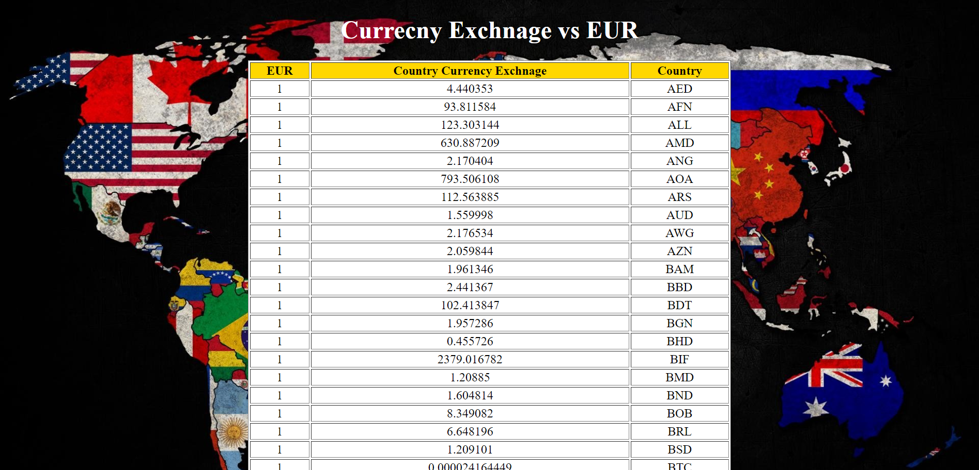

**Major Steps / Test**

The major steps in this question are as followed.

* First create the HTML skeleton
* Create a script tag in the body to do JS in
* Inside we declare two methods for use
* The first method is called load doc and is called when the page loads
* This method declares and object of XMLHttpRequest()
* It has declared a function to be called anytime the ready state value changes for the XHTTP object
* Once the object ready state is equal to 4 and the status is equal to 200 (meaning the connection is made correctly) then call myfunction, and pass the xhttp object to it.
* We also have the open and send method we use to establish the ajax connection – set to true for async and reference the api URL (the connection destination)
* Inside the function myfunction, we declare an object – jsonDoc and set it to the xhttp object we passed to this method with the response type of text (for JSON)
* After this we declare a second var myObj and set it to JSON.parse(jsonDoc), parsing the xhttp object from above.
* Next, we declare some variable for work, referencing their element name inside the object we created.
* We set up the column headers for the table
* Then we use a for each loop through the entire object (in this case the rates object in the json doc)
* Then we retrieve the data we need and return it in a table format

I test these outputs using console log and alerts to see what elements and values are returned.

For example, I was able to easily return the base currency, EUR, and the other countries’ currencies respected exchange rate vs the euro However, it was harder to display the key associated with that value, in other words the country that currency belonged to.

Through lots of trial an error to the console I was able to display the corresponding key for each value in the browser.

# Question 5 and 7(Bonus) : XSLT and XPath

(Describe the major steps for designing the XSLT. How did you use XPath in the XSLT?

Add screenshot of the XPath testing and the output of XSLT)

**BY: TIM BURNS**

**QUESTION 5**

**CODE**

<?xml*version*="1.0"*encoding*="UTF-8" ?>

<xsl:stylesheet *version*="1.0" *xmlns:xsl*="http://www.w3.org/1999/XSL/Transform">

   <xsl:template *match*="/">

      <html>

         <head>

            <title>Title of the page</title>

            <style>

            div {

                        width: 50%;

                        margin: 0 auto;

                        text-align: center;

                     }

                     body{

                        background-image: url("https://images6.alphacoders.com/400/thumb-1920-400645.jpg");

                        background-size: contain;

                     }

            </style>

         </head>

         <body>

         <div>

            <h1 *style*='color: white'>List of Country info</h1>

            <table *border* = "1" *style*='background-color: white; width: 100%'>

            <tr *BGCOLOR*= "gold">

               <th>

                  Country Name

               </th>

               <th>

                  Capital

               </th>

               <th>

                  Unemployment %

               </th>

               <th>

                  Total GDP

               </th>

            </tr>

            <xsl:for-each *select* = "//country">

            <tr>

               <td>

                  <xsl:value-of *select*="name"/>

               </td>

               <td>

                  <xsl:value-of *select*="@capital"/>

               </td>

               <xsl:choose>

               <xsl:when *test*="count(unemployment)!=1"> <!-- when statement checker -->

                        <td *style*='background-color: red'>

                           N/A

                        </td>

               </xsl:when>

               <xsl:otherwise>

                        <td *style*='background-color: white'>

                           <xsl:value-of *select*="unemployment"/>

                        </td>

               </xsl:otherwise>

               </xsl:choose>

               <xsl:choose>

               <xsl:when *test*="count(gdp_total)!=1"> <!-- when statement checker -->

                        <td *style*='background-color: red'>

                           N/A

                        </td>

               </xsl:when>

               <xsl:otherwise>

                        <td *style*='background-color: white'>

                           <xsl:value-of *select*="gdp_total"/>

                        </td>

               </xsl:otherwise>

               </xsl:choose>

            </tr>

            </xsl:for-each>

            </table>

            </div>

         </body>

      </html>

   </xsl:template>

</xsl:stylesheet>

**OUTPUT (NOT ALL IN SCREEN SHOT)**

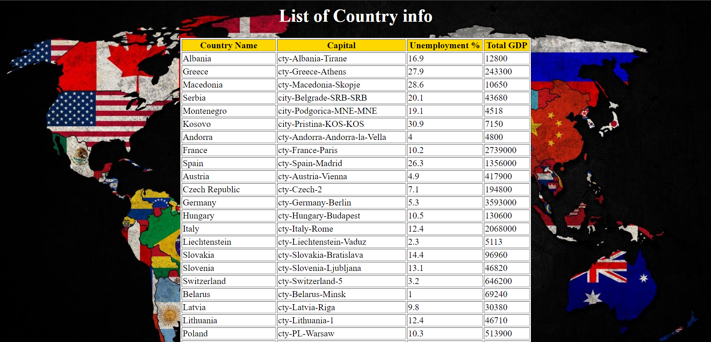

**Major Steps / XPath**

The major steps in this question are as followed.

* First you must link the XML doc to the XSLT doc (done on the xml doc side)
* Inside the XSLT doc you need to create the template for work
* Inside you can use html tags to display the data you want in the format you want
* First, we create the title and the headers for our table data
* Next, we use the for-each XSLT element to loop through all the countries
* We use the value of XSLT element and select the values we want to extract
* For example, “name” for the name element in the xml doc and “@capital” for the attribute from the xml doc
* Then we need to use a choose when otherwise block to handle the scenarios where unemployment and GDP are not available for that country.
* To do this we use to choose when otherwise blocks
* For example, unemployment, we specify when the count of unemployment is not equal to one(meaning it does not exist) then print N/A otherwise get the inform from the unemployment element in the XML doc
* This is done in the exact same way to handle GDP
* After this, you close all the opened tags and you data will be displayed

I test these outputs using an XPath tester (https://www.freeformatter.com/xpath-tester.html) to see the path to retrieve the data I needed.

Once I developed the proper XPath I used that as a reference point to pull the data from the xml doc by using XSLT elements.

Simply develop a working XPath and use that as a reference to pull data from the file.

**XPath Testing**

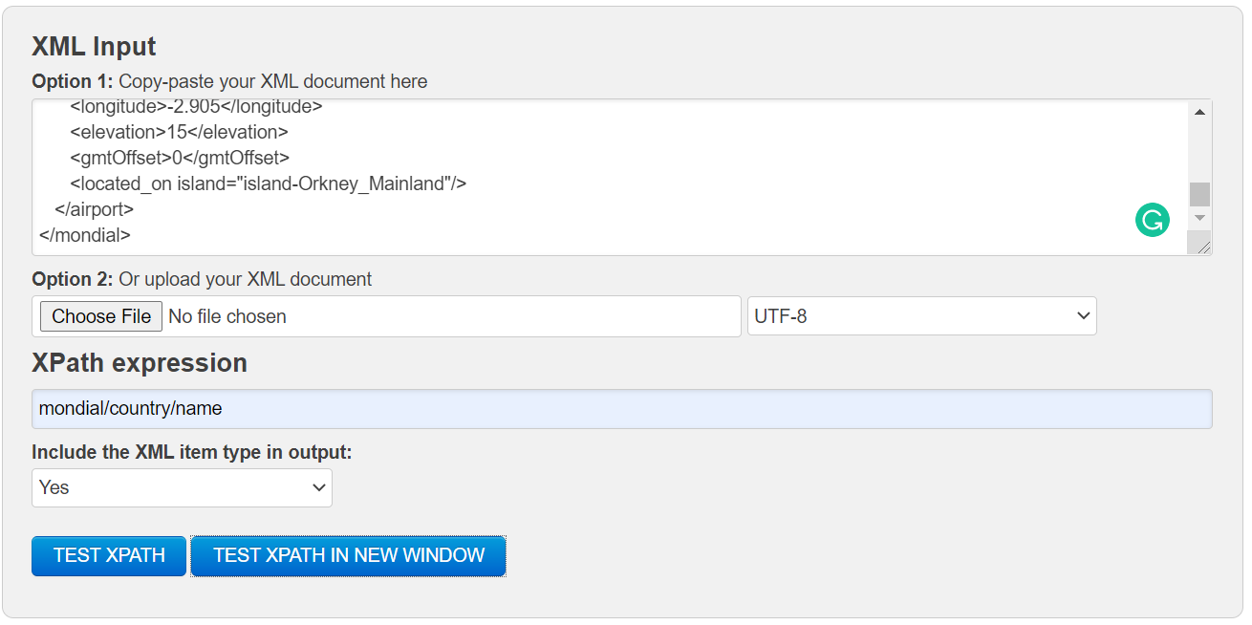

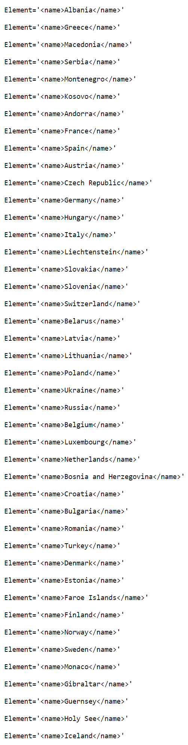

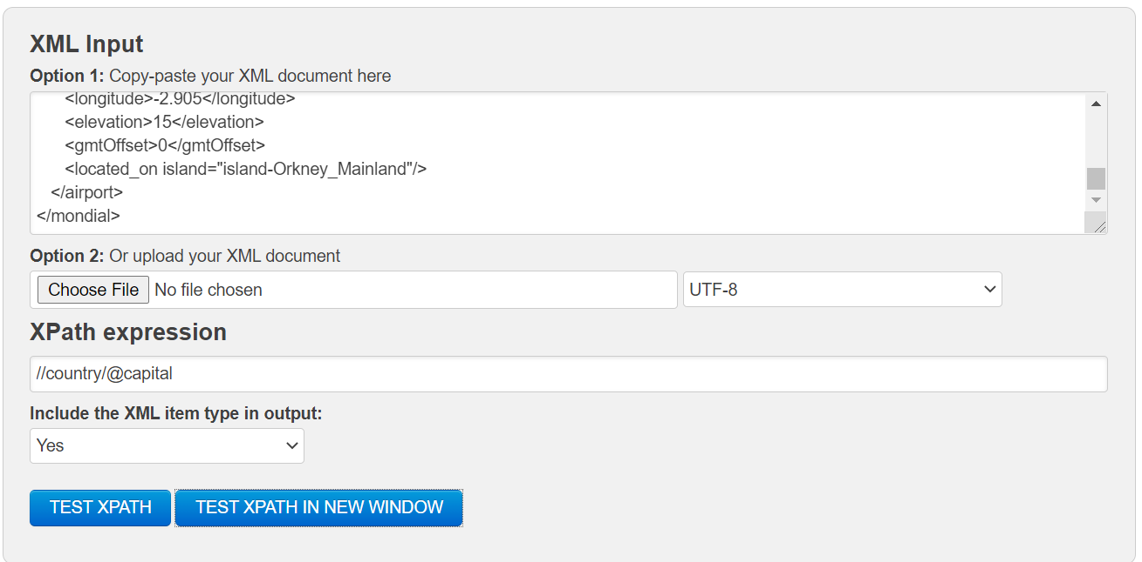

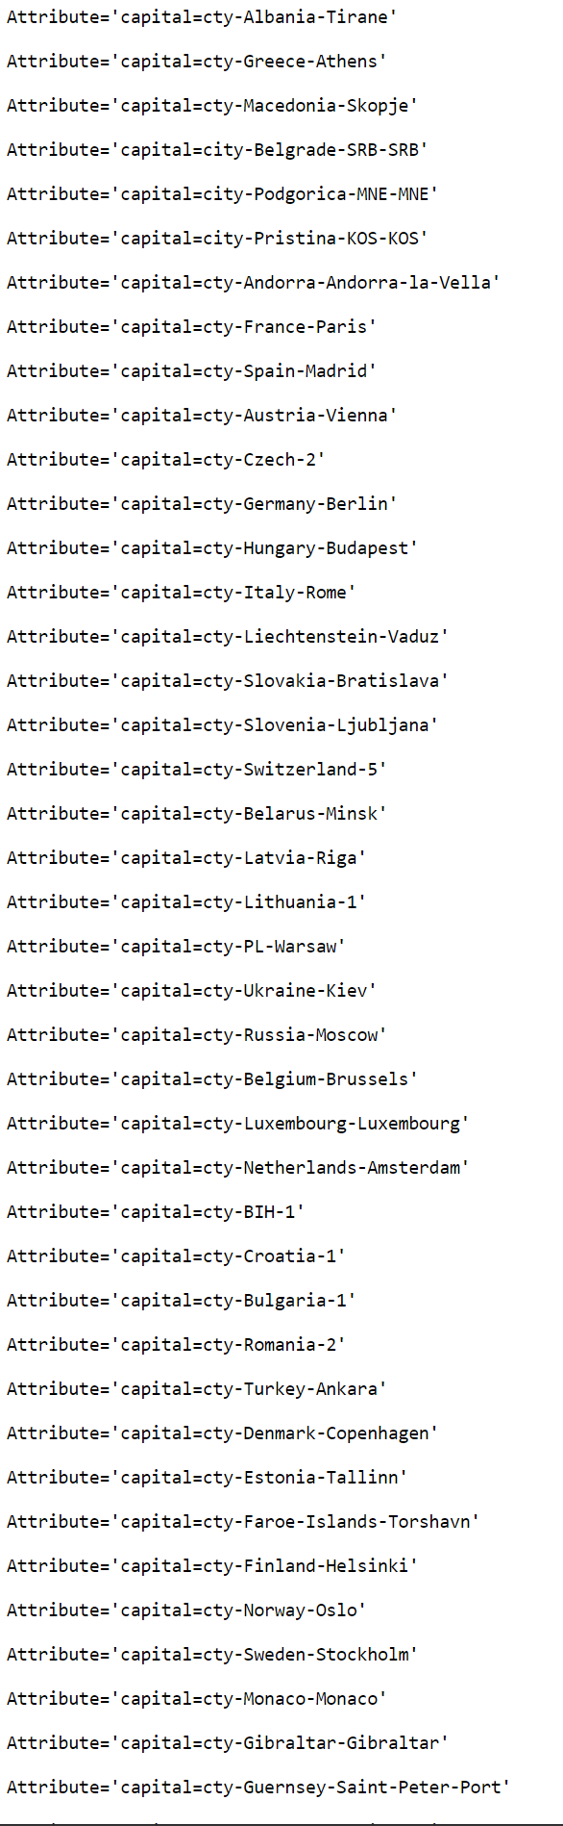

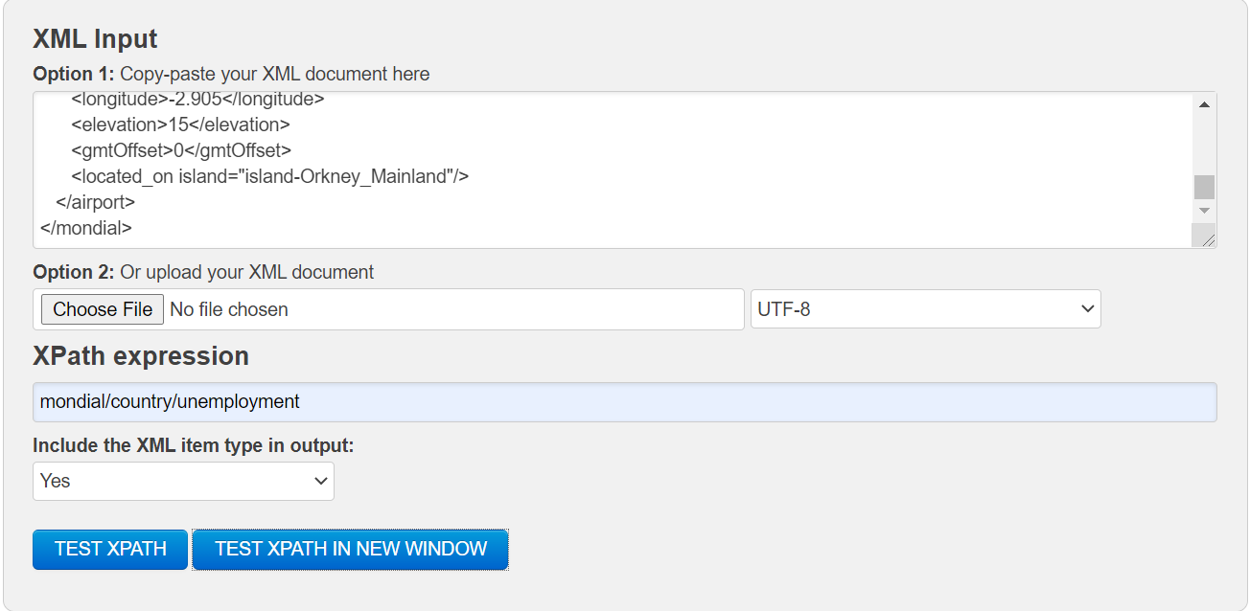

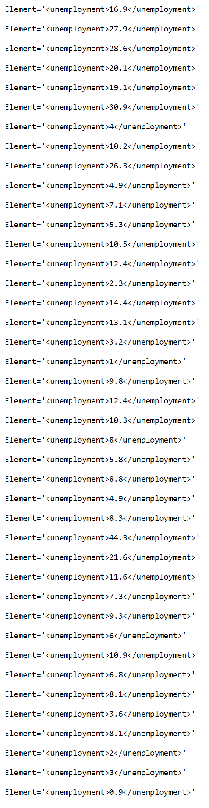

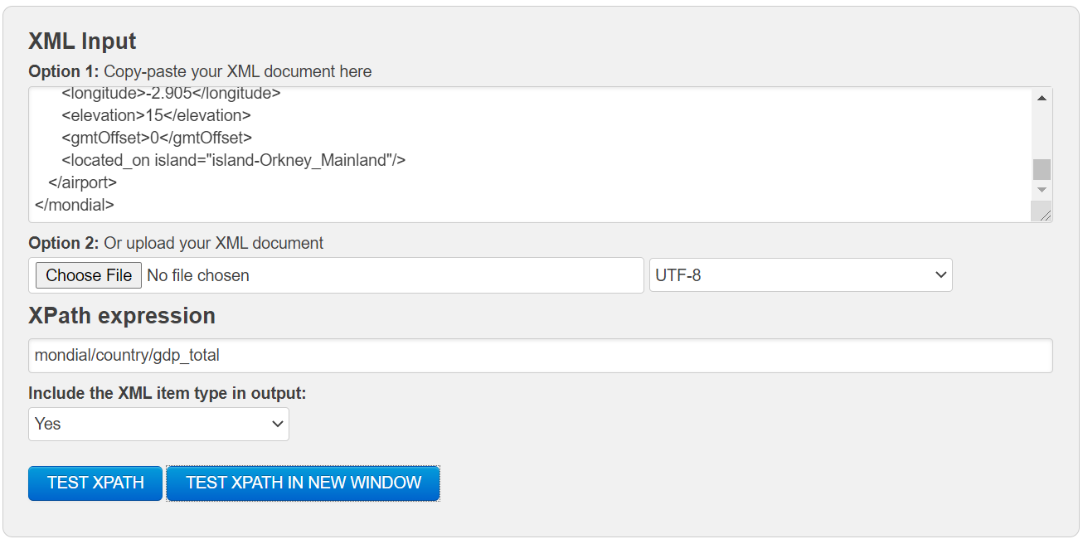

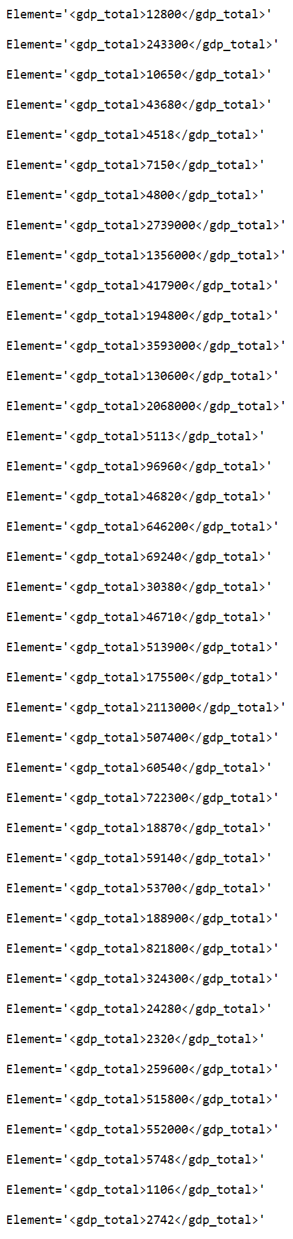

**BY: TIM BURNS**

**QUESTION 7**

**CODE**

<?xml*version*="1.0"*encoding*="UTF-8" ?>

<xsl:stylesheet *version*="1.0" *xmlns:xsl*="http://www.w3.org/1999/XSL/Transform">

   <xsl:template *match*="/">

      <html>

         <head>

            <title>Title of the page</title>

            <style>

            div {

                        width: 50%;

                        margin: 0 auto;

                        text-align: center;

                     }

                     body{

                        background-image: url("https://images6.alphacoders.com/400/thumb-1920-400645.jpg");

                        background-size: contain;

                     }

            </style>

         </head>

         <body>

         <div>

            <h1 *style*='color: white'>List of Country info</h1>

            <table *border* = "1" *style*='background-color: white ; width: 100%'>

            <tr *BGCOLOR*= "gold">

               <th>

                  Province Name

               </th>

               <th>

                  Local Name

               </th>

               <th>

                  Population (2011)

               </th>

               <th>

                  No of cities in the province

               </th>

            </tr>

            <xsl:for-each *select* = "//province">

            <tr>

               <td>

                  <xsl:value-of *select*="name"/>

               </td>

               <xsl:choose>

               <xsl:when *test*="count(localname)!=1"> <!-- when statement checker -->

                        <td *style*='background-color: red'>

                           N/A

                        </td>

               </xsl:when>

               <xsl:otherwise>

                        <td *style*='background-color: white'>

                           <xsl:value-of *select*="localname"/>

                        </td>

               </xsl:otherwise>

               </xsl:choose>

               <xsl:choose>

               <xsl:when *test*="count(population[@year='2011'])!=1"> <!-- when statement checker -->

                        <td *style*='background-color: red'>

                           N/A

                        </td>

               </xsl:when>

               <xsl:otherwise>

                        <td *style*='background-color: white'>

                           <xsl:value-of *select*="population[@year='2011']"/>

                        </td>

               </xsl:otherwise>

               </xsl:choose>

               <td>

                  <xsl:value-of *select*="count(city)"/>

               </td>

            </tr>

            </xsl:for-each>

            </table>

            </div>

         </body>

      </html>

   </xsl:template>

</xsl:stylesheet>

**OUTPUT (NOT ALL IN SCREEN SHOT)**

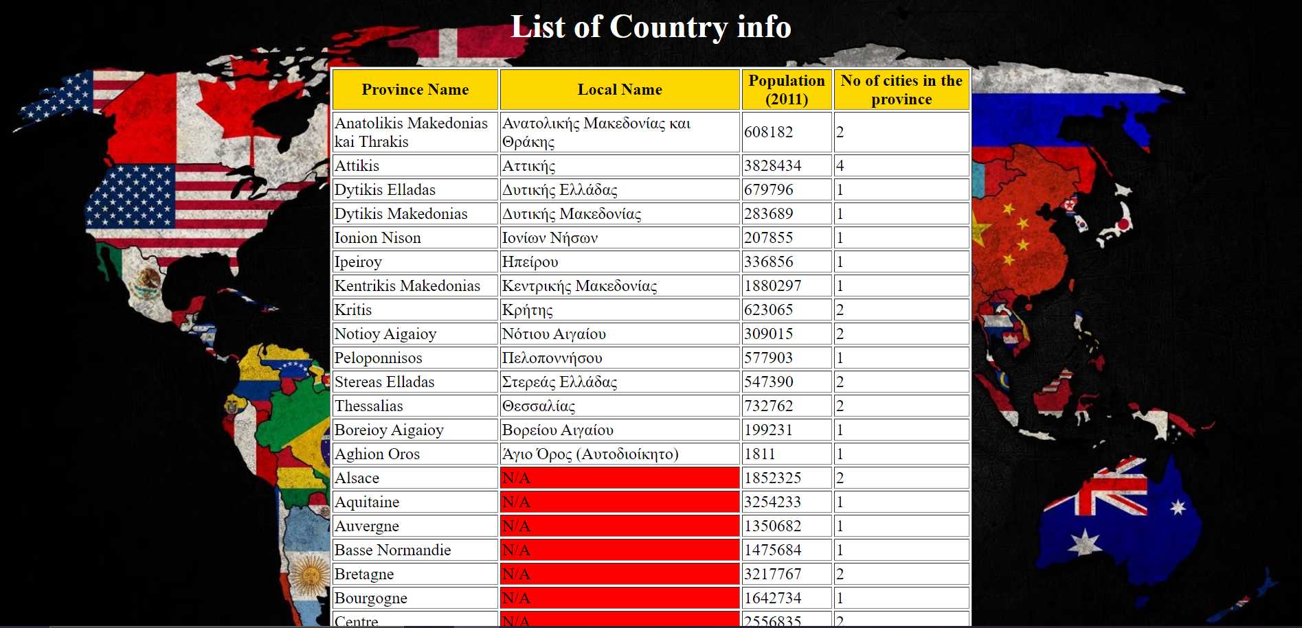

**Major Steps / Test**

The major steps in this question are as followed.

* First you must link the XML doc to the XSLT doc (done on the xml doc side)
* Inside the XSLT doc you need to create the template for work
* Inside you can use html tags to display the data you want in the format you want
* First, we create the title and the headers for our table data
* Next, we use the for-each XSLT element to loop through all the provinces
* PH
* We use the value of XSLT element and select the values we want to extract
* For example, “name” for the name element belong to province in the xml doc and count(city) for the elements holding the city info from the xml doc
* Then we need to use a choose when otherwise block to handle the scenarios where “local name” and the *population census of 2011* are not available for that country.
* To do this we use to choose when otherwise blocks
* For example, local name, we specify when the count of local name is not equal to one (meaning it does not exist) then print N/A otherwise get the inform from the local name element in the XML doc
* This is done in a similar way to handle population, except this time we include the attribute year =2011 in the count
* If it is not equal to 1 then print NA otherwise get the info from the xml doc
* After this, you close all the opened tags and you data will be displayed

I test these outputs using an XPath tester (https://www.freeformatter.com/xpath-tester.html) to see the path to retrieve the data I needed.

Once I developed the proper XPath I used that as a reference point to pull the data from the xml doc by using XSLT elements.

Simply develop a working XPath and use that as a reference to pull data from the file.

**XPath**

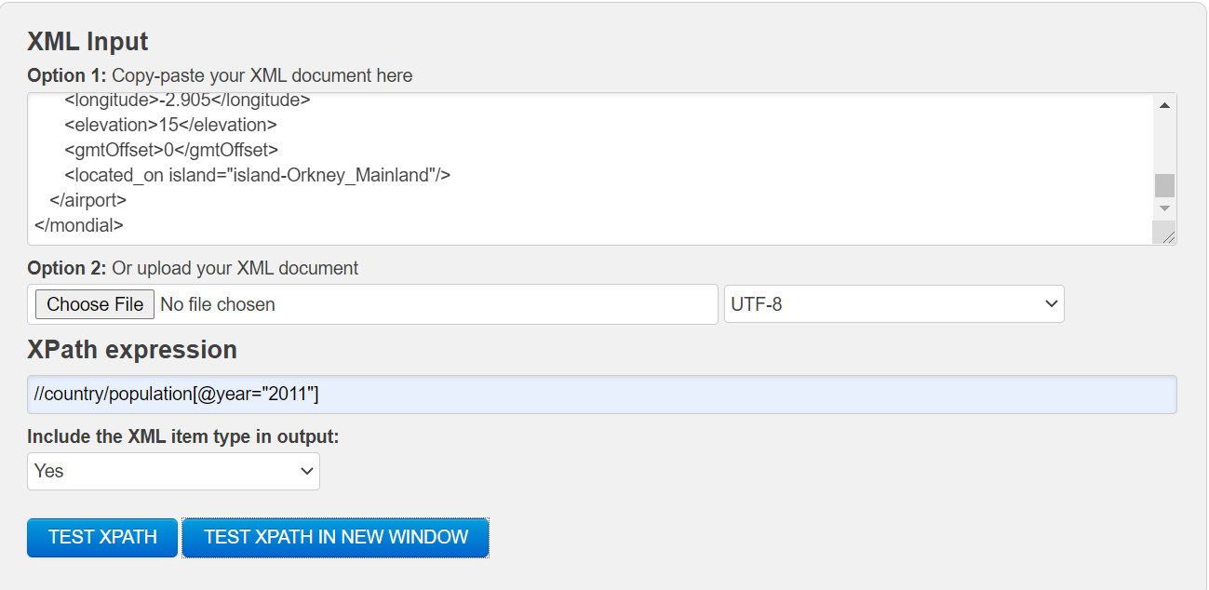

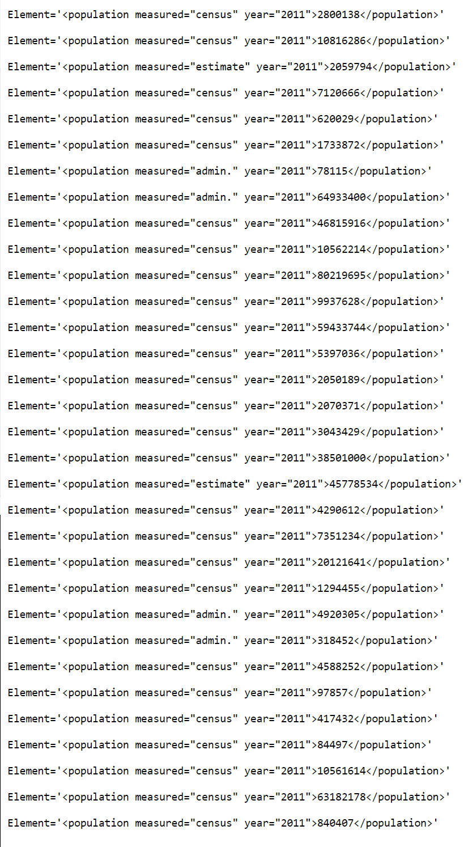

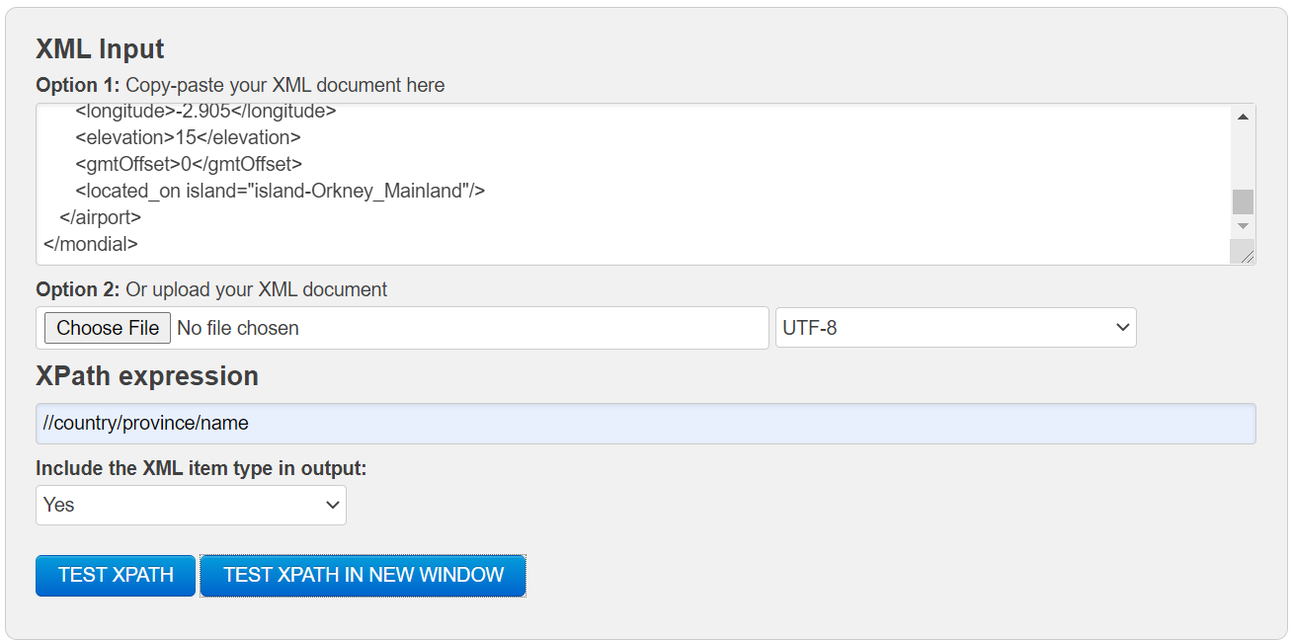

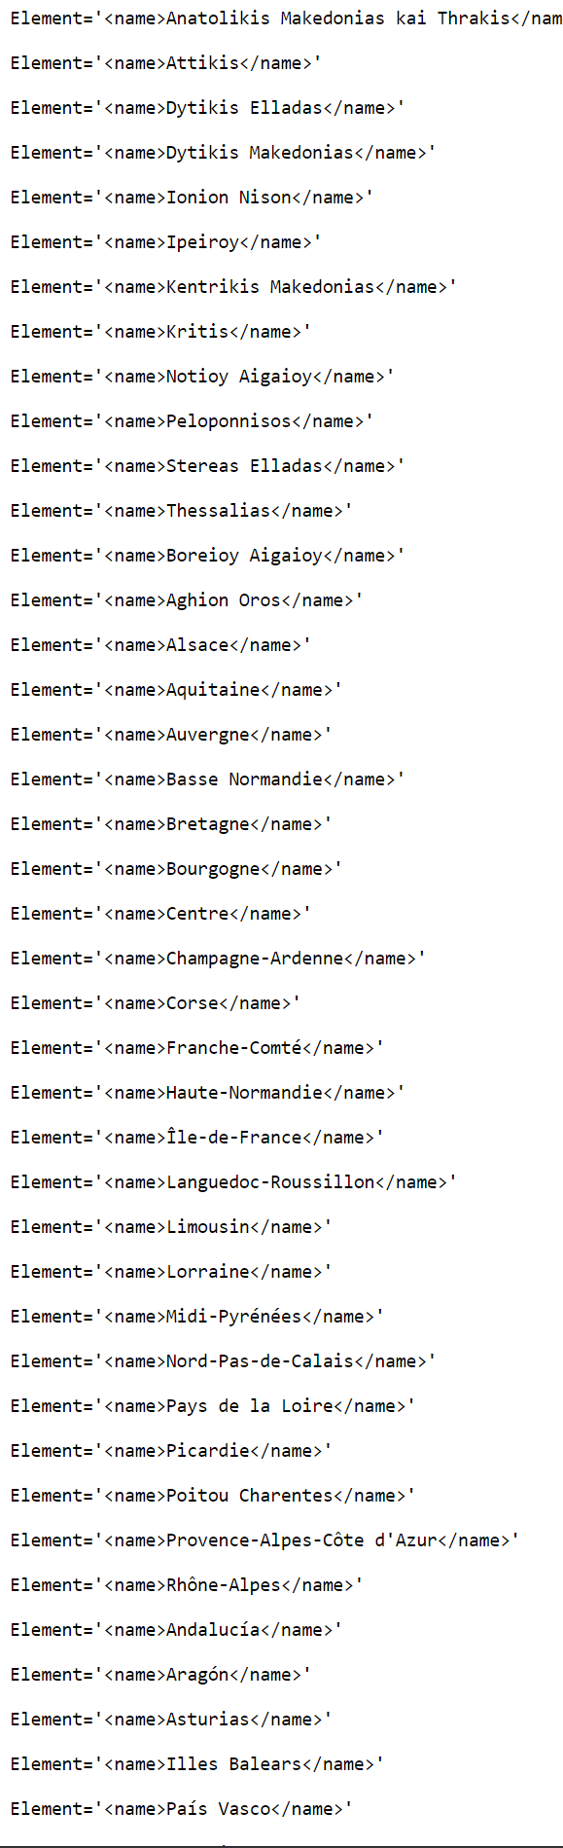

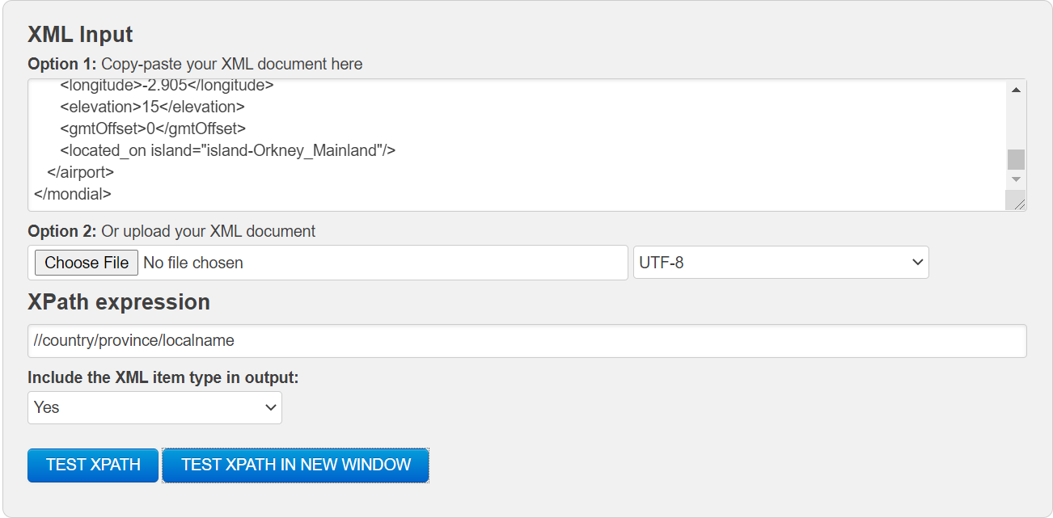

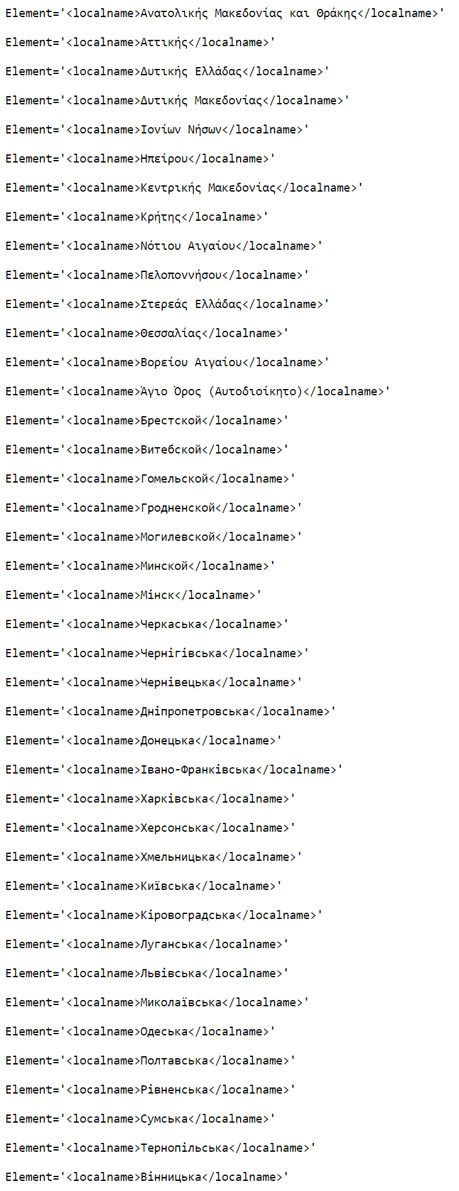

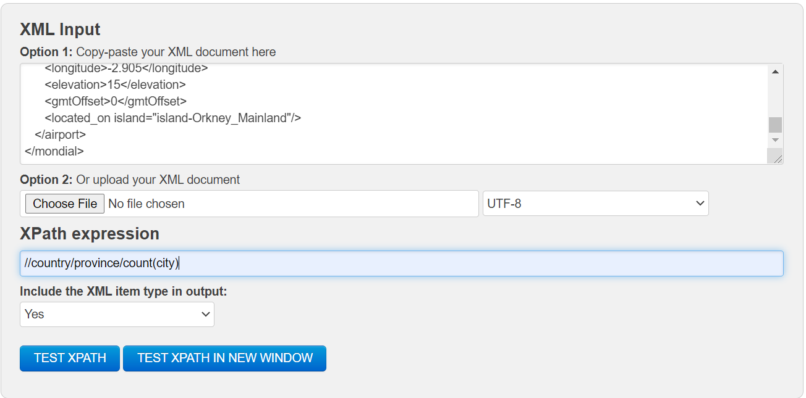

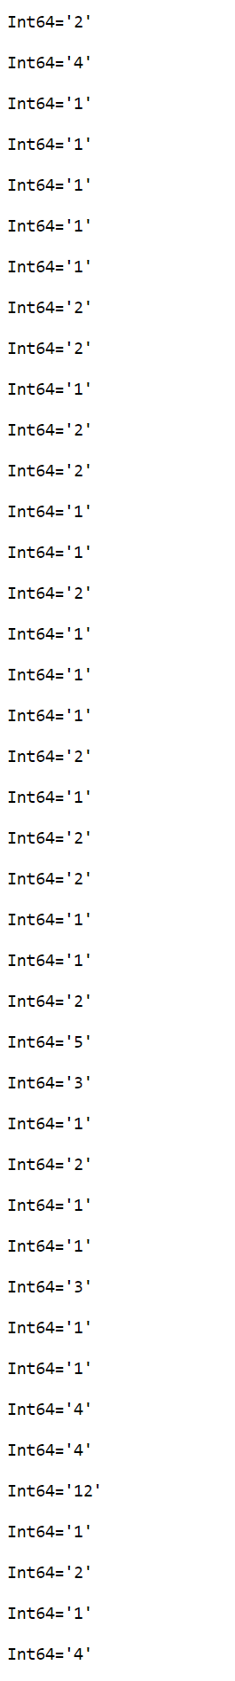

# Summary

(Describe how did you divide the work, share your feedback about this project like new points that you learn, challenges, …)

**Tim Summary**

We divided the work as fairly as we could, I took questions 1,3,5 & attempted 7 and Devansh took questions 2,4 & 6. This way we both tackled some hard questions and had roughly the same amount of work, of course helping each other when we could.

This project I found very challenging for some questions and easier for others. For example, the first question was very difficult to maneuver through the xml doc as it was such a mishmash of data and format.

It took several hours of trial and error and trying to understand the doc before I was able to retrieve and handle the exceptions for the data I needed. I struggled with handling the even retrieving the name of countries and excluding the names of cities at first before I finally had the right combination that was displayed in console, which I later implemented into the code. Unemployment and GDP were also a struggle at first, as I tried to make their respective index represented by I in the for loop, before I realized I needed to use zero instead and handle for the times it does not exist.

I also struggled with question 3 on how to display the key value pairs in a way that would show the currency exchange rate vs the EUR and the respective country tag it belonged to. After doing research, I was able to find a method that worked for me and got the desired results.